**Intro to vectors**

* *Representing a point in a space*

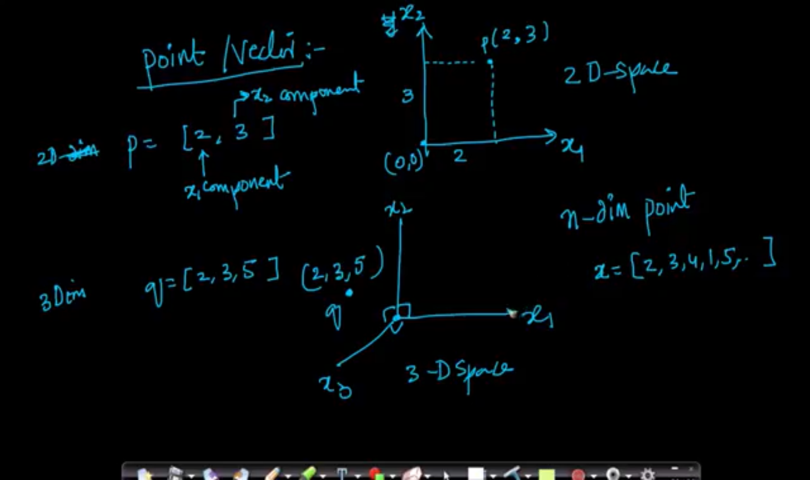

* *Distance of a point from Origin*

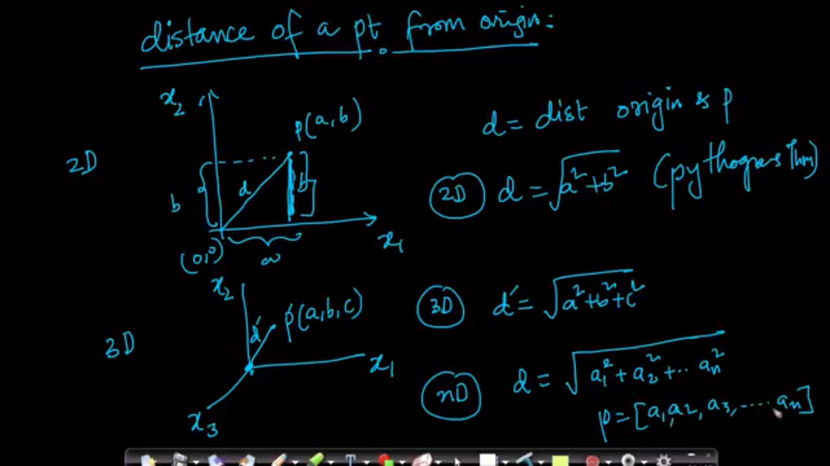

* *Distance between two points:*

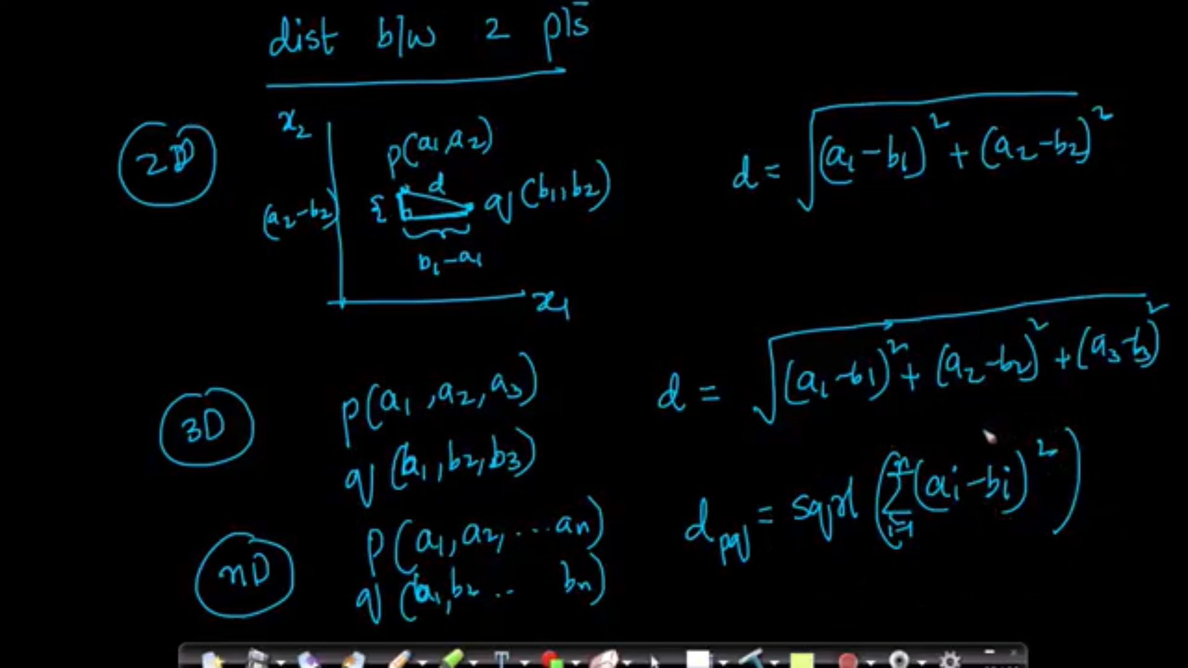

* *Row Vector and Column Vector*

